 **Nitte Meenakshi Institute of Technology**

(AN AUTONOMOUS INSTITUTION AFFILIATED TO VISVESVARAYA TECHNOLOGICAL UNIVERSITY, BELGAUM)

PB No. 6429, Yelahanka, Bangalore 560-064, Karnataka

Telephone: 080- 22167800, 22167860

Fax: 080 – 22167805



**OOPS COURSE MINI-PROJECT REPORT**

on

**ATM DATA MANAGEMENT**

*Submitted in partial fulfilment of the requirement for the award of Degree of*

*Bachelor of Engineering in*

## Artificial Intelligence and Data Science

Submitted by:

|  |  |
| --- | --- |
| Shreyansh Jaiwal | 1NT21AD050 |



**Department of AI&DS**

2021-2025

**DECLARATION**

We hereby declare that

(i)This presentation does not contain text, graphics or tables copied and pasted from the Internet, unless specifically acknowledged and the source being detailed in the report and in the reference’s sections.

(ii)All corrections and suggestions indicated during the interval presentation have been incorporated in the report.

(iii)Content of the report has been checked for the plagiarism requirement .

**ABSTRACT**

ATMs are Automated Teller Machines that are used to carry day-to-day financial transactions. ATMs can be used to withdraw money or to deposit money or even to know the information of an account like the balance amount, etc. They are convenient and easy to use, it allows consumers to perform quick self-service transactions.

In this Project, we will discuss the ATM Management System in C++ which is an application that provides users with every aspect that an actual Automated Teller Machine i.e., ATM should have. It is a menu-driven program having ATM functions which include:

* Enter Name, Account number, Account type to be shown during transactions.
* Shows the information about the person who is doing the transaction.
* Enter amount to deposited in the account.
* Shows the Balance in the account.
* Enter amount to be withdrawn from the account, and then it shows available balance.
* Cancel the transaction.

**TABLE OF CONTENTS**

**Page Nos.**

**CHAPTER 1: INTRODUCTION-------------------------------------------------x**

* 1. History and background---------------------------------------------------------------x
  2. Motivation--------------------------------------------------------------------------------x
  3. Objectives-------------------------------------------------------------------------------- x

**CHAPTER 2: OVERVIEW OF THE PROJECT---------------------------------x**

* 1. ATM Data Management--------------------------------------------------------------------------x
  2. Working of the project-----------------------------------------------------------------x

**CHAPTER 3: DESIGN AND IMPLEMENTATION----------------------------x**

* 1. Flow diagram of the project----------------------------------------------------------x
  2. Software requirements ----------------------------------------------------------------x
  3. Code-----------------------------------------------------------------------------------------x
  4. Snapshots----------------------------------------------------------------------------------x

**CHAPTER 4: CONCLUSION AND FUTURE WORK------------------------x**

* 1. Conclusion------------------------------------------------------------------------------x
  2. Future work----------------------------------------------------------------------------x

**CHAPTER 5: REFERENCES------------------------------------------------------x**

**CHAPTER 1: INTRODUCTION**

* 1. **History and background**[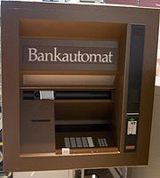](http://en.wikipedia.org/wiki/File:FrÃ¼her_Bankautomat_von_Nixdorf.jpg)

The first mechanical cash dispenser was developed and built by Luther George Simjian and installed in 1939 in New York City by the City Bank of New York, but removed after 6 months due to the lack of customer acceptance.

Thereafter, the history of ATMs paused for over 25 years, until De La Rue developed the first electronic ATM, which was installed first in Enfield Town in North London, United Kingdom on 27 June 1967 by Barclays Bank. This instance of the invention is credited to John Shepherd-Barron, although various other engineers were awarded patents for related technologies at the time. Shepherd-Barron was awarded an OBE in the 2005 New Year's Honours List. The first person to use the machine was the British variety artist and actor Reg Varney.

* 1. **Motivation**

The technological and performance arguments for networks based on a general topology interconnection of ATM switches have been, and continue to be, fully represented in the literature. Switches with 160 Mbit/s line rates and aggregate capacities of several Gbit/s are now feasible with current technology, offering a packet switched service at rates previously only associated with STM networks. Small scale switches for private and LAN use are now becoming available; in our environment we use switches varying in size from 4 by 4 to 16 by 16 developed within the Fairisle project. Designs for larger switches such as required for public networks present interesting scaling problems.

**1.3 Objectives**

The project to be designed will control a simulated automated teller machine (ATM) having a magnetic stripe reader for reading an ATM card, a customer console (keyboard and display) for interaction with the customer, a slot for depositing envelopes, a dispenser for cash, a printer for printing customer receipts, and a key-operated switch to allow an operator to start or stop the machine. The ATM will communicate with the bank's computer over an appropriate communication link. Design the ATM system in detail with the architectural design. Use cases, sequence diagrams, class structural models and behavioral models.

**CHAPTER 2: OVERVIEW OF THE PROJECT**

**2.1 ATM Data Management**

ATM (Automatic Teller Machine) is a banking terminal that accepts deposits and dispenses cash. ATMs are activated by inserting cash (in cases of ATM Depositing) or debit /credit card that contain the user's account number and PIN on a magnetic stripe (for cash withdrawals).The ATM is made of the CPU (microprocessor)

**2.2 Working of the project**

As this is software it can be used by a wide variety of banks to automate the process of manually maintaining the records related to the each transaction of bank account holder. The main goal of this application is to provide very reliable & efficient service to bank account holder at any time & any location.

This system will cover the following modules,

1. Cash Withdrawal.

2. Balance Enquiry.

3. Mini Statement.

4. PIN Change.

5. Cash Deposit.

6. Loan Information.

7. Help Menu.

**CHAPTER 3: DESIGN AND IMPLEMENTATION**

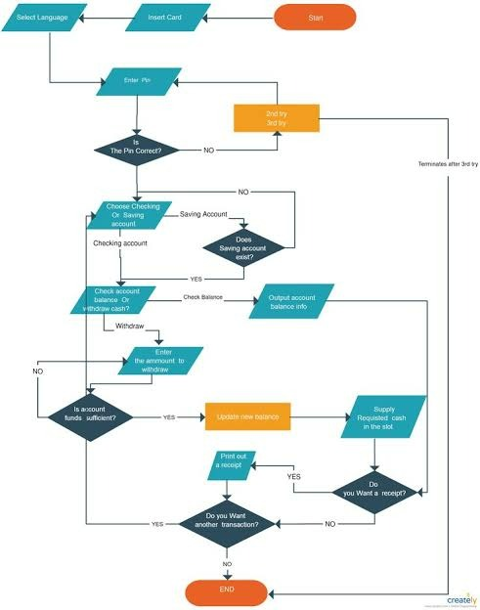

**CHAPTER 5: BIBLIOGRAPHY**

➢ Referred Books:

• “The Complete Reference in C++” by Herb Schildt -4

th edition,

TMH, 2005

• “C++ Primer” ,Stanley B Lippman, 4th edition, Addison Wesley,

2005

• “Object Oriented Programming With C++” , Sourav Sahey, Oxford

University, 2006

➢ Referred Links:

• www.wikipedia.com

• www.stackoverflow.com

• www.geeksforgeeks.com

• [www.edureka.com](http://www.edureka.com)